

CZ3006/CSC302 : Net - Centric Computing

Assignment 2

Prepared by:

Kok Jian Rong Kelvin

U1421727F (TS3)

COMPUTER SCIENCE COURSE

SCHOOL OF COMPUTER ENGINEERING

NANYANG TECHNOLOGICAL UNIVERSITY

**Design description**

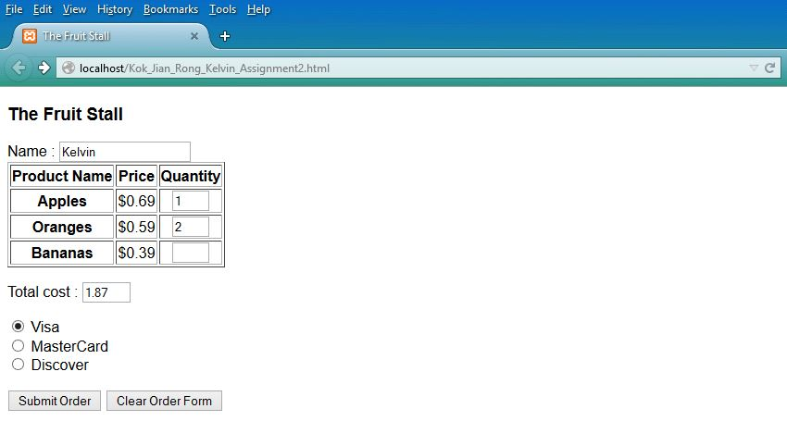

HTML file

The design in this HTML file is pretty straight forward. A text box is placed at the start of the form for the user to enter his name, which is mandatory.

After that, the fruits available and their prices are shown in a table. The user can then enter the quantity he wishes to order for that particular fruit. At least one fruit must be ordered in order to place an order. The non-editable text box below the table will update the total cost accordingly. If the user enters anything besides a positive whole number, the text box will display NaN, indicating that the total cost cannot be calculated because at least one value in the three textboxes above does not contain a positive whole number.

The user will then need to select the mode of payment. ‘The radio button ‘Visa’ will be selected by default. Only one mode of payment can be selected.

The ‘Clear Order Form’ is a button which will erase all the values in the textboxes above. Once ready, the user can click on ‘Submit Order’ to proceed with the order. Any errors made will be shown and the user will need to make changes accordingly before the order is placed.

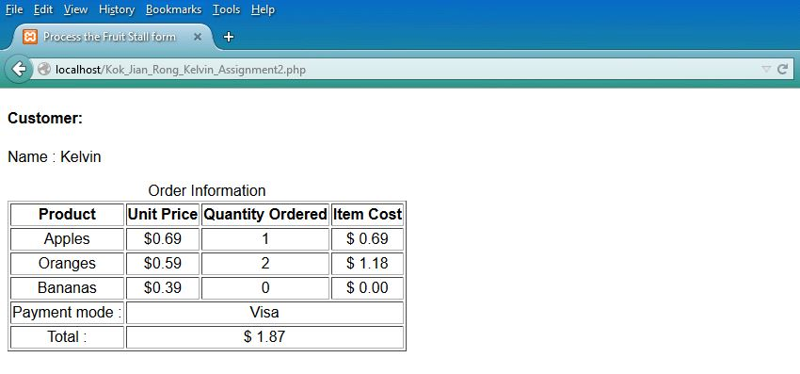

PHP file

Once the user clicks on the submit button, he will be brought to the next page, which is the PHP. Here, the details of the order will be shown. The user’s name will be displayed on top. Next, the quantity and total price of each fruit ordered, the mode of payment and the total price the user has to pay will be shown in a table.

**Listing**

Kok_Jian_Rong_Kelvin_Assignment2.html

Kok_Jian_Rong_Kelvin_Assignment2.php

**Code description**

HTML file

In the HTML file, the user will place his order. The function computeCost() will check that the user does not enter any characters other than numbers in the text box. If he does, the submit button will be disabled until the user keys in a positive whole number. A text box showing ‘NaN’ shows the user that the value keyed in is an invalid value. If the user enters a valid value, the text box will show the total price of the fruits, rounded to 2 decimal place. Entering a valid value will also enable the submit button again.

The user must input his name before proceeding. An order should consist of the name of the person who placed it. If no name is detected, the user will be prompted to enter his name when he clicks the submit button. This is checked by the function validateForm().

The user must also order at least one fruit. Otherwise, it would be an empty order. If no fruit(s) is ordered, the user will be prompted to order at least one fruit when he clicks the submit button. This is checked by the function validateForm().

PHP file

In the PHP file, values passed from the HTML form will be received. The total price of the fruits will be calculated again here. Then, the name of the user, quantities and prices of the respective fruits ordered, mode of payment and total price of all fruits ordered will be displayed.

The number of fruits every user orders will be accumulated and stored into a text file. The file will be opened and read line by line. Each line with replaced by “”, except for numbers. The numbers will then be converted into integers and summed with the quantities of the current order, before it is written back into the file.

**HTML codes**

<?xml version = "1.0" encoding = "utf-8" ?>

<!DOCTYPE html PUBLIC "-//w3c//DTD XHTML 1.0 Strict//EN"

"http://www.w3.org/TR/xhtml1/DTD/xhtml1-strict.dtd">

<!-- nochange.html

This document illustrates using the focus event

to prevent the user from changing a text field

-->

<html xmlns = "http://www.w3.org/1999/xhtml">

<head> <title> The Fruit Stall </title>

<script type = "text/javascript">

<!--// The event handler function to compute the cost

function computeCost() {

var apples = document.getElementById("apples").value;

var oranges = document.getElementById("oranges").value;

var bananas = document.getElementById("bananas").value;

var totalCost=apples * 0.69 + oranges * 0.59 + bananas * 0.39;

var totalCostRoundUp=totalCost.toFixed(2); //rounds the total amount of money to 2 d.p

document.getElementById("cost").value = totalCostRoundUp;

document.getElementById("submit").disabled = false; //enables the submit button

//if user does not key in number, the submit button will be disabled in the 'if' condition

if(isNaN(apples) || isNaN(oranges) || isNaN(bananas) || apples%1!=0 || oranges%1!=0 || bananas%1!=0 || apples<0 || oranges<0 || bananas<0)//if any of the text boxes contain non-digit,decimal or negative values

{

document.getElementById("cost").value = "NaN";

alert("Please positive whole numbers only!");

}

// Compute the cost

} //* end of computeCost

-->

function validateForm() {

var apples = document.getElementById("apples").value;

var oranges = document.getElementById("oranges").value;

var bananas = document.getElementById("bananas").value;

var name = document.getElementById("name").value;

var cost= document.getElementById("cost").value;

if(name=="")

{

alert("Please enter your name!");

return false;

}

if((apples =="" && oranges=="" && bananas=="") ||(cost==0.00))

{

alert("Please order at least 1 fruit!");

return false;

}

if(isNaN(apples) || isNaN(oranges) || isNaN(bananas) || apples%1!=0 || oranges%1!=0 || bananas%1!=0 || apples<0 || oranges<0 || bananas<0)//if any of the text boxes contain non-digit,decimal or negative values

{

document.getElementById("cost").value = "NaN";

alert("Please positive whole numbers only!");

return false;

}

}

</script>

</head>

<body>

<form action = "Kok_Jian_Rong_Kelvin_Assignment2.php"

method ="post">

<h3> The Fruit Stall </h3>

<table border = "border">

Name : <input type = "text" id = "name" name="name"

size ="20" "/>

<tr>

<th> Product Name </th>

<th> Price </th>

<th> Quantity </th>

</tr>

<tr>

<th> Apples </th>

<td> $0.69 </td>

<td align = "center"> <input type = "text" id = "apples" name="apples"

size ="3" onchange="computeCost()"/> </td>

</tr>

<tr>

<th> Oranges </th>

<td> $0.59 </td>

<td align = "center"> <input type = "text" id = "oranges" name="oranges"

size = "3" onchange="computeCost()"/> </td>

</tr>

<tr>

<th> Bananas </th>

<td> $0.39 </td>

<td align = "center"> <input type = "text" id = "bananas" name="bananas"

size = "3" onchange="computeCost()"/></td>

</tr>

</table>

<p>

Total cost :

<input type = "text" size = "5" id = "cost" name="cost"

onfocus = "this.blur();" />

</p>

<p>

<input type = "radio" name = "payment" value = "Visa" checked = "checked"/>

Visa

<br />

<input type = "radio" name = "payment" value = "MC" />

MasterCard

<br />

<input type = "radio" name = "payment" value = "Discover"/>

Discover

<br />

</p>

<p>

<input type = "submit" value = "Submit Order" onclick="return validateForm();" id="submit" />

<input type = "reset" value = "Clear Order Form" />

</p>

</form>

</body>

</html>

**PHP codes**

<?xml version = "1.0" encoding = "utf-8" ?>

<!DOCTYPE html PUBLIC "-//w3c//DTD XHTML 1.0 Strict//EN"

"http://www.w3.org/TR/xhtml1/DTD/xhtml1-strict.dtd">

<html xmlns = "http://www.w3.org/1999/xhtml">

<head>

<title> Process the Fruit Stall form </title>

</head>

<body>

<?php

// Get form data values

$name = $_POST["name"];

$apples = $_POST["apples"];

$oranges = $_POST["oranges"];

$bananas = $_POST["bananas"];

$payment = $_POST["payment"];

// If any of the quantities are blank, set them to zero

if ($apples == "") $apples = 0;

if ($oranges == "") $oranges = 0;

if ($bananas == "") $bananas = 0;

// Compute the item costs and total cost

$apples_cost = 0.69 * $apples;

$oranges_cost = 0.59 * $oranges;

$bananas_cost = 0.39 * $bananas;

$total_cost=$apples_cost+ $oranges_cost+$bananas_cost;

// Return the results to the browser in a table

?>

<h4> Customer: </h4>

<?php

print ("Name : $name <br />");

?>

<p /> <p />

<table border = "border">

<caption> Order Information </caption>

<tr>

<th> Product </th>

<th> Unit Price </th>

<th> Quantity Ordered </th>

<th> Item Cost </th>

</tr>

<tr align = "center">

<td> Apples </td>

<td> $0.69 </td>

<td> <?php print ("$apples"); ?> </td>

<td> <?php printf ("$ %4.2f", $apples_cost); ?>

</td>

</tr>

<tr align = "center">

<td> Oranges </td>

<td> $0.59 </td>

<td> <?php print ("$oranges"); ?> </td>

<td> <?php printf ("$ %4.2f", $oranges_cost); ?>

</td>

</tr>

<tr align = "center">

<td> Bananas </td>

<td> $0.39 </td>

<td> <?php print ("$bananas"); ?> </td>

<td> <?php printf ("$ %4.2f", $bananas_cost); ?>

</td>

</tr>

<tr align = "center">

<td> Payment mode :

</td>

<td colspan="3"> <?php printf ($payment); ?>

</td>

</tr>

<tr align = "center">

<td> Total :

</td>

<td colspan="3"> <?php printf ("$ %4.2f", $total_cost); ?>

</td>

</tr>

</table>

<p /> <p />

<?php

$apple = $_POST["apples"];

$orange = $_POST["oranges"];

$banana = $_POST["bananas"];

//opens the file and read line by line

$myfile_line = file("order.txt" );

//if it is an empty text file, fills every row with empty space to prevent error

for ($x = 0; $x <= 10; $x++) {

if(empty($myfile_line[$x]))

$myfile_line[$x]=" ";

}

//replaces anything which is not a number with "" line by line

$apples_cumulative=preg_replace("/[^0-9]/","",$myfile_line[0]);

$oranges_cumulative=preg_replace("/[^0-9]/","",$myfile_line[1]);

$bananas_cumulative=preg_replace("/[^0-9]/","",$myfile_line[2]);

//sums the existing value in the text file and the newly entered value

$apples_total=$apple+ (int)$apples_cumulative;

$oranges_total=$orange+(int)$oranges_cumulative;

$bananas_total=$banana+(int)$bananas_cumulative;

//contents to be written back to the file

$apples_content="Total number of apples: $apples_total\r\n";

$oranges_content="Total number of oranges: $oranges_total\r\n";

$bananas_content="Total number of bananas: $bananas_total\r\n";

//writes back into the file

$file = fopen("order.txt","w+");

fwrite ($file,$apples_content);

fwrite ($file,$oranges_content);

fwrite ($file,$bananas_content);

fclose($file);

?>

</body>

</html>